Homework2 Part-1
Leo Lu
2024-11-13
Table of Contents

Brief Overview of the Data
# Data Loading
diamonds <- read_csv("Diamonds Prices2022.csv")
## New names:
## Rows: 53943 Columns: 11
## -- Column specification
## -------------------------------------------------------- Delimiter: "," chr
## (3): cut, color, clarity dbl (8): ...1, carat, depth, table, price, x, y, z
## i Use `spec()` to retrieve the full column specification for this data. i
## Specify the column types or set `show_col_types = FALSE` to quiet this message.
## * `` -> `...1`
# Data Preview
head(diamonds)
## # A tibble: 6 x 11
## ...1 carat cut color clarity depth table price x y z
## <dbl> <dbl> <chr> <chr> <chr> <dbl> <dbl> <dbl> <dbl> <dbl> <dbl>
## 1 1 0.23 Ideal E SI2 61.5 55 326 3.95 3.98 2.43
## 2 2 0.21 Premium E SI1 59.8 61 326 3.89 3.84 2.31
## 3 3 0.23 Good E VS1 56.9 65 327 4.05 4.07 2.31
## 4 4 0.29 Premium I VS2 62.4 58 334 4.2 4.23 2.63
## 5 5 0.31 Good J SI2 63.3 58 335 4.34 4.35 2.75
## 6 6 0.24 Very Good J VVS2 62.8 57 336 3.94 3.96 2.48
# Adjusting Data
diamonds = diamonds[,-1]
str(diamonds)
## tibble [53,943 x 10] (S3: tbl_df/tbl/data.frame)
## $ carat : num [1:53943] 0.23 0.21 0.23 0.29 0.31 0.24 0.24 0.26 0.22 0.23 ...
## $ cut : chr [1:53943] "Ideal" "Premium" "Good" "Premium" ...
## $ color : chr [1:53943] "E" "E" "E" "I" ...
## $ clarity: chr [1:53943] "SI2" "SI1" "VS1" "VS2" ...
## $ depth : num [1:53943] 61.5 59.8 56.9 62.4 63.3 62.8 62.3 61.9 65.1 59.4 ...
## $ table : num [1:53943] 55 61 65 58 58 57 57 55 61 61 ...
## $ price : num [1:53943] 326 326 327 334 335 336 336 337 337 338 ...
## $ x : num [1:53943] 3.95 3.89 4.05 4.2 4.34 3.94 3.95 4.07 3.87 4 ...
## $ y : num [1:53943] 3.98 3.84 4.07 4.23 4.35 3.96 3.98 4.11 3.78 4.05 ...
## $ z : num [1:53943] 2.43 2.31 2.31 2.63 2.75 2.48 2.47 2.53 2.49 2.39 ...
diamonds$cut = factor(diamonds$cut,
levels = c('Fair', 'Good', 'Very Good', 'Premium', 'Ideal'))
diamonds$color = factor(diamonds$color,
levels = c('D', 'E', 'F', 'G', 'H', 'I', 'J'))
diamonds$clarity = factor(diamonds$clarity,
levels = c('I1', 'SI2', 'SI1', 'VS2', 'VS1', 'VVS2', 'VVS1', 'IF'))
str(diamonds)
## tibble [53,943 x 10] (S3: tbl_df/tbl/data.frame)
## $ carat : num [1:53943] 0.23 0.21 0.23 0.29 0.31 0.24 0.24 0.26 0.22 0.23 ...
## $ cut : Factor w/ 5 levels "Fair","Good",..: 5 4 2 4 2 3 3 3 1 3 ...
## $ color : Factor w/ 7 levels "D","E","F","G",..: 2 2 2 6 7 7 6 5 2 5 ...
## $ clarity: Factor w/ 8 levels "I1","SI2","SI1",..: 2 3 5 4 2 6 7 3 4 5 ...
## $ depth : num [1:53943] 61.5 59.8 56.9 62.4 63.3 62.8 62.3 61.9 65.1 59.4 ...
## $ table : num [1:53943] 55 61 65 58 58 57 57 55 61 61 ...
## $ price : num [1:53943] 326 326 327 334 335 336 336 337 337 338 ...
## $ x : num [1:53943] 3.95 3.89 4.05 4.2 4.34 3.94 3.95 4.07 3.87 4 ...
## $ y : num [1:53943] 3.98 3.84 4.07 4.23 4.35 3.96 3.98 4.11 3.78 4.05 ...
## $ z : num [1:53943] 2.43 2.31 2.31 2.63 2.75 2.48 2.47 2.53 2.49 2.39 ...

Random Sample
set.seed(111)
index = sample(1:nrow(diamonds), size = 500, replace = F)
diamonds_sample = diamonds[index, ]

Data Summarize
pairs(diamonds_sample)
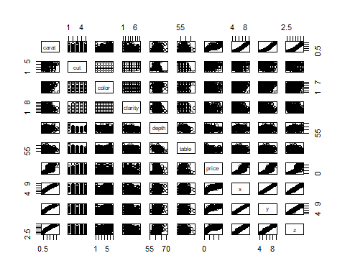

Variables Description

Cut [Categorical variable that discribes the quality of the cut (Fair, Good, Very Good, Premium, Ideal)]
ggplot(diamonds_sample, aes(x = cut)) +
geom_bar(fill = "turquoise", color = "navyblue") +
labs(title = "Frequency Distribution of Diamond Cut Quality", x = "Cut Quality",
y = "Frequency") + theme_minimal()
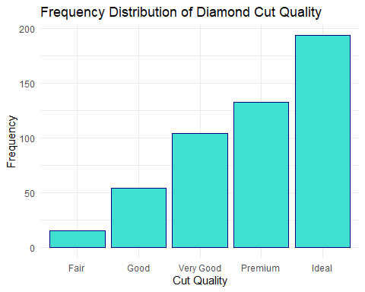 Comment: The barplot of the cut variable shows that the majority of diamonds are in higher quality categories like ‘Very Good’, ‘Premium’, and ‘Ideal’. This left-skewed distribution indicates a dataset preference for diamonds with better cut quality.

Color [Categorical variable that describes the quality of the diamond color, graded from D (best) to J (worst)]
ggplot(diamonds_sample, aes(x = color)) +
geom_bar(fill = "turquoise", color = "navyblue") +
labs(title = "Frequency Distribution of Diamond Color Quality", x = "Color Quality",
y = "Frequency") + theme_minimal()
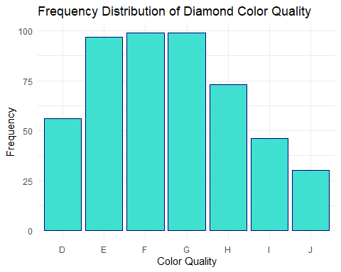 Comment: We can see from the bar plot that the grades E, F, and G are the most common, indicating a preference for mid-range rather than extreme color quality diamonds. Thus, it might be bimodal or multimodal distribution.

Carat [Quantitative variable that values the weight of the diamond (0.2-5.01)]
ggplot(diamonds_sample, aes(x = carat)) +
geom_histogram(binwidth = 0.1, fill = "turquoise", color = "navyblue") +
labs(title = "Frequency Distribution of Carat Weight", x = "Carat", y = "Frequency") +
theme_minimal()
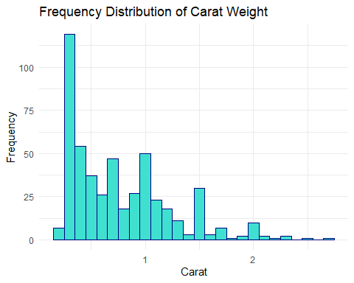 Comment: The distribution is right-skewed, with a high frequency of smaller carat weights around 0.5, followed by a gradual decrease in frequency as carat weight increases. It shows that smaller diamonds are more popular in the dataset compared to larger ones.

Depth [Quantitative variable that values the total depth percentage (z/mean(x,y)=2*z/(x+y)(43-79)]
ggplot(diamonds_sample, aes(x = depth)) +
geom_histogram(binwidth = 0.5, fill = "turquoise", color = "navyblue") +
labs(title = "Frequency Distribution of Depth Percentage", x = "Depth Percentage",
y = "Frequency") + theme_minimal()
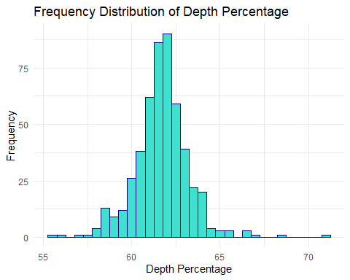 Comment: This is approximately normally distributed, centered around 61% and most values falling between 59% and 63%. It indicates that most diamonds in the dataset tend to have identical depth proportions.

Price [Quantitative variable that values the price of the diamond in US dollars ($326-$18,823)]
ggplot(diamonds_sample, aes(x = price)) +
geom_histogram(binwidth = 1000, fill = "turquoise", color = "navyblue") +
labs(title = "Frequency Distribution of Price", x = "Price (USD)", y = "Frequency") +
theme_minimal()
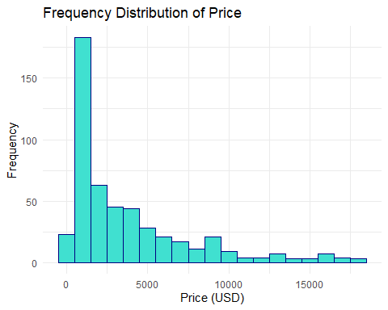 Comment: This shows a right-skewed distribution, with a high concentration of diamonds priced below $2000. This indicates that lower-priced diamonds are more common, while high-priced diamonds are less frequent, indicating that expensive diamonds are not popular in this dataset.

Correlation Analysis

Two Quantitative Variables
ggplot(diamonds, aes(x = carat, y = price)) +
geom_point(alpha = 0.5, color = "coral") +
scale_x_continuous(limits = c(0, 6)) +
labs(title = "Scatterplot of Price vs. Carat",
x = "Carat (ct)",
y = "Price (USD)") +
theme_minimal()
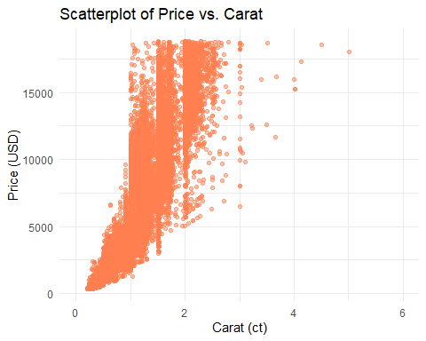 Comment: There is a clear positive correlation, where price tends to increase with carat size. The plot also reveals variability in prices for similar carat weights, indicating that other factors besides carat contribute to the price. There are some clusters of data around certain carat weights indicate that the diamonds of these weights are more common.

Quantitative and Categorical Variables
ggplot(diamonds_sample, aes(x = cut, y = depth, fill = cut)) +
geom_violin(trim = FALSE) +
geom_boxplot(width = 0.1, color = "black", position = position_dodge(0.9)) +
labs(title = "Violin Plot of Cut vs. Depth",
x = "Cut Quality",
y = "Depth (%)") +
theme_minimal()
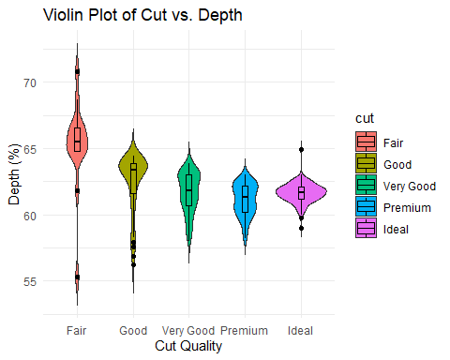 Comment: The distribution for “Fair” cut has the widest spread, and it become more compact as the cut quality becomes better, indicating more consistency in depth. The median depth decreases as cut quality becomes better slightly, suggesting that depth vary, but not significantly between cuts.

Two Categorical Variables
cut_color <- table(diamonds_sample$cut, diamonds_sample$color)
cut_color
##
## D E F G H I J
## Fair 1 1 4 0 4 3 2
## Good 9 12 6 8 9 6 4
## Very Good 10 24 21 20 16 7 6
## Premium 13 27 22 31 20 11 9
## Ideal 23 33 46 40 24 19 9
Comment: There is positive association between higher cut quality and more common colors. Ideal and Premium cuts have the highest counts across most color grades, indicating that higher-quality cuts tend to be more prevalent. Lower cut quality like Fair has fewer diamonds across all color grades, suggesting a preference in the dataset towards higher quality.

Visualizing Correlation Matrix
library(corrplot)
## corrplot 0.95 loaded
cor_matrix <- cor(diamonds %>% select_if(is.numeric))
corrplot(cor_matrix, method="color", col=colorRampPalette(c("blue", "white",
"red"))(200), type="upper", tl.col="black", tl.srt=45,
addCoef.col = "black")
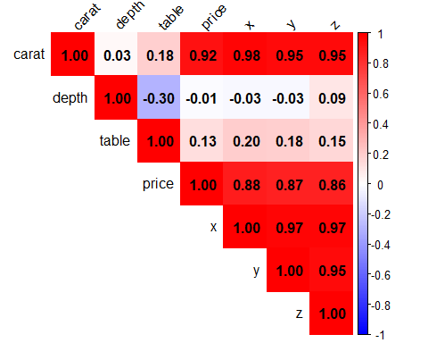
cor_matrix[c("price","depth","table"),c("price","depth","table")]
## price depth table
## price 1.00000000 -0.01063007 0.1271179
## depth -0.01063007 1.00000000 -0.2957980
## table 0.12711786 -0.29579799 1.0000000

Multiple Linear Regression
fit <- lm(price ~ carat + depth + cut + color, data = diamonds_sample)
summary(fit)
##
## Call:
## lm(formula = price ~ carat + depth + cut + color, data = diamonds_sample)
##
## Residuals:
## Min 1Q Median 3Q Max
## -6675.8 -698.7 -83.0 513.7 6762.9
##
## Coefficients:
## Estimate Std. Error t value Pr(>|t|)
## (Intercept) -187.19 3307.78 -0.057 0.954894
## carat 7972.82 151.47 52.635 < 2e-16 ***
## depth -66.20 49.99 -1.324 0.186050
## cutGood 1368.39 462.50 2.959 0.003240 **
## cutVery Good 1687.72 456.32 3.699 0.000242 ***
## cutPremium 2040.26 461.39 4.422 1.21e-05 ***
## cutIdeal 2125.51 445.81 4.768 2.46e-06 ***
## colorE 296.14 251.38 1.178 0.239343
## colorF 261.08 251.03 1.040 0.298847
## colorG 260.31 251.56 1.035 0.301272
## colorH -410.42 268.93 -1.526 0.127633
## colorI -591.30 309.28 -1.912 0.056477 .
## colorJ -1606.87 344.25 -4.668 3.94e-06 ***
## ---
## Signif. codes: 0 '***' 0.001 '**' 0.01 '*' 0.05 '.' 0.1 ' ' 1
##
## Residual standard error: 1493 on 487 degrees of freedom
## Multiple R-squared: 0.8579, Adjusted R-squared: 0.8544
## F-statistic: 245.1 on 12 and 487 DF, p-value: < 2.2e-16

Observations
- Carat weight has the largest positive coefficient. This indicates that the carat of diamonds is the most significant predictor.
- There is a gap between the coefficient of colorJ and colorI, which shows that colorJ is normally have a significantly decrease in the value of the diamonds.
- As expected, the price is in a positive correlation with the increase in the quality of cut and color.
- The Multiple R-squared is 0.8579, which represents that nearly 86% of the variance of price can be explained by this model. This shows a generally good fit.
- The depth influence least the price of the diamond which is kind of surprising
- Since there is a large F(245.1), shows that all coefficients of the variables are significant.
- The different between the coefficients of the cut qualities “ideal” and “Premium” is not that significant compared with other qualities. I suppose that they should be approximately similar, which is kind of surprising.

